Trouble Shooting Problems & Proper Directions for Using



Bio-Extreme™ High Temperature Oven Lubricants
ISO 46, 68, 100, 150, 220 H1, H2

Introduction to the Problems
Historically, high temperature oven chains have been a challenge to lubricant design engineers. There are many variables including different oven sizes and designs, many different types of lube systems, different chain sizes and designs, etc. The oven drives can run the chain at different speeds and the temperature can vary considerably from 100°C to over 1000°C. No single formulation with one viscosity can properly service the multitude of different markets and applications. Food grade oven chain lubricants increase the problem because Food Grade requirements limit the allowable H1 components that can be used to provide proper performance. Past technology includes PAOs and synthetic esters with additional extreme pressure/antiwear additives. Typically, lube devices had to be set to continually supply these lubricants to keep the chain wet and lubricated properly. Complaints in the field included two different deposit problems; hard deposits from mineral based and PAO based formulations that could seize-up a chain and soft deposits from synthetic ester based that created an over build up from continually supplying the lubricant to keep the chain wet and properly lubricated. Cleaning of these chains require high maintenance and prolonged downtime.
Because these formulations fail to perform at the higher temperatures, solid additives including moly and graphite have been used with some improvement. However, these have been problematic in meeting H1 food grade requirements and the black, dirty, and messy deposit that these solid lubricants leave has led to many complaints. Cleaning is also a major problem with these materials, especially in food processing plants, not to mention the burn off of these materials inside the oven in direct contact with the food. In fact many of the components being used in food oven lubricants are not listed as HX1 for H1 and do not comply with the FDA’s 21 CFR 178.3570 lubricants for incidental food contact requirements. This raises major issues with food liability coming out of food processing plants, along with environmental issues for non-food applications including total loss lubricant markets.
Regardless of which of these lubricants are used, customer complaints in the field are being reported that chains still get dirty and wear because of the many variables that create problems in lubricating at the high oven temperatures.
General Problems When Lubricating High Temperature Oven Chains
- Improper placement of lubricant on the chain.
- Lube device over lubricating causing excessive build-up on the chain.
- Improper viscosity in relation to lube device/system and chain size.
- Improper agitation of the lubricant that provides inconsistent viscosity and/or solid lubricant.
- Improper selection of “too heavy viscosity” oil not penetrating into the lubricant areas of the links, pins and rollers but staying on the outside causing build-up
- Plugged lube system due to improper micron size and or solid lubricant separation
- Poor lube device design with improper control and placement on the chain
- Poor maintenance of the lube system and chain

Directions for Using Bio-Extreme High Temperature Oven Lubricants

Do Not Over Lubricate- The Bio-Extreme High Temperature Oven Lubricants provide cost savings and less clean up when used properly. Technicians from the field have reported with proper maintenance and lube device settings, these lubricants can be reduced to approximately ¼ the normal rates of previous lubricants. In one application the chain ran two days without re-lubrication compared to constant lubrication required from a conventional black graphite product.

- Apply directly to moving surfaces of the chain links, pins and rollers (use proper viscosity that stays on chain, and penetrates into pins and rollers)
- Apply normal rate for first few hours or until links, pins and rollers are wet with lubricant (check to see if the lubricant has penetrated into links, pins and rollers)
- In most ovens after normal rate is applied automatic lube systems can be reduced to approximately ¼ the normal rate of most oven lubricants
- Steady rate lube systems and lube systems with timers can be adjusted down by monitoring amperage increases of the chain drive unit
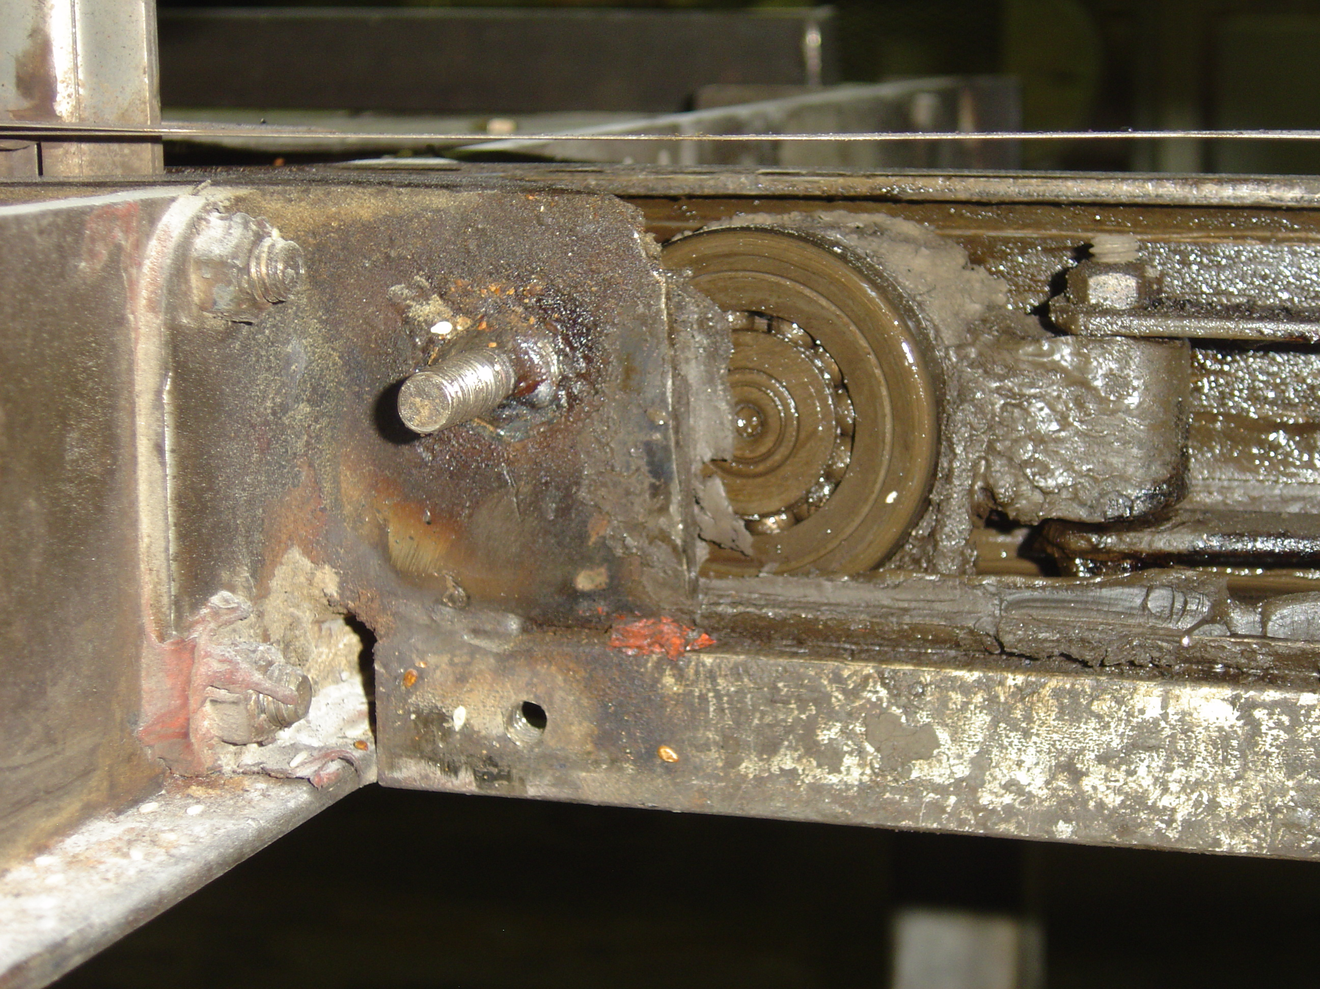

Photo of over Applying Lubricants
Factors to Consider

Optimum Viscosity- is provided by the Super High Viscosity Index (VI) that gives energy efficiency and optimum lubrication at higher operating temperatures. The chart in the technical data sheet shows the exceptional viscosity performance of the Bio-HT Oven Lubricant ISO 220 (VI of 184) compared to a conventional petroleum based lubricant ISO 220 (VI 95). Bio-HT Oven Lubricants provide a lighter fluid at room temperature, but maintains double the fluid film (viscosity in cSt) over 100C. Because of this super high viscosity index and energy conserving properties the viscosity @ < 20°C will be less than half of the viscosity in the lube device system over a lower VI conventional formulation. The Bio-Extreme HT viscosity is dependent upon the temperature of the location of the lube device.

Respectfully submitted,

William W. Garmier

